3D Shape Questions
OCR Thursday 8 November 2018 – Morning (Non-Calculator) Foundation Tier

OCR Thursday 2 November 2017– Morning (Calculator) Foundation Tier

OCR Sample Question Paper 2 – Morning/Afternoon (Non - Calculator) Foundation Tier

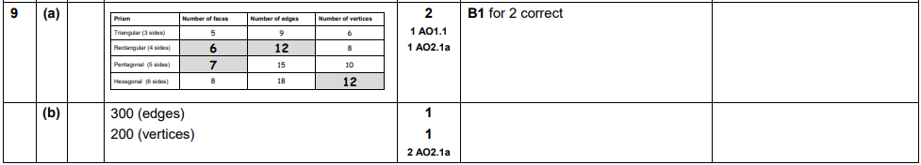

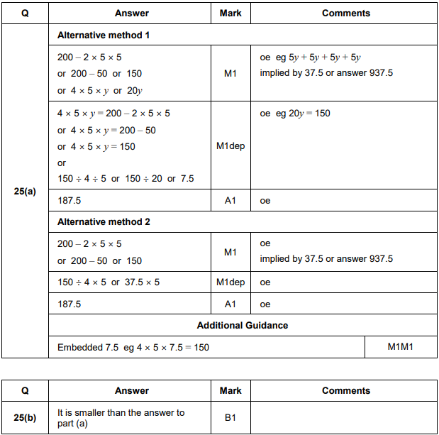

AQA Tuesday 21 May 2019 – Morning (Non-Calculator) Foundation Tier

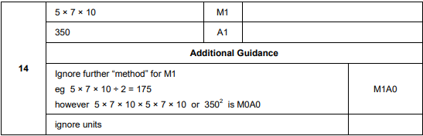
AQA Sample Paper 2– Morning (Calculator) Foundation Tier

